# Third grade – First term

# Math symbols

<https://www.canva.com/design/DAG2oUrIL7U/chwfuCOTEIKxTB-mQU_cLQ/view?utm_content=DAG2oUrIL7U&utm_campaign=designshare&utm_medium=link2&utm_source=uniquelinks&utlId=h7737ef6b17>

# 2. Sets

## What is a set

* **What is a set?**
  + <https://www.twinkl.com.co/teaching-wiki/set-mathematics>
  + <https://www.mathsisfun.com/sets/sets-introduction.html>
* **What is the cardinal of a set?**

The cardinality of a set is simply how many items are in it, like counting how many toys are in a box. For example, if you have the set of {a, b, c}, it has 3 items, so its cardinality is 3. To find the cardinality, you just count the number of things in the set. It's the "how many" number for a group of things.

Cardinality is the "size" of a set

**How to find it:** Count all the objects in the set. The last number you say is the cardinality.

**Example:** For the set {red block, blue block, yellow block}, the cardinality is 3.

**Unique items:** If an item is listed more than once in a set, you only count it once. For the set {apple, banana, apple}, there are only 2 unique items, so the cardinality is 2.

## Suggested activities:

* Create your own set, why is a set?
* Identify 6 sets in your house and explain why they are sets.
* Cardinal: aquí quiero que coloques conjuntos con cierto número de objetos y que haya una casilla en la que el estudiante pueda verificar si su respuesta es correcta o no. Minimo unos 8 sets, pero que se abra en una ventanita como emergente en el sitio web y que.
* Worksheets: https://www.mathsdiary.com/match-the-sets/#google_vignette

## Games:

* <https://wordwall.net/es/resource/78528970/math/sets-of-objects>
* <https://wordwall.net/es/resource/7178922/math/number-sets>
* <https://wordwall.net/es/resource/62246840/shape-sets>

# Word Problems

## UPAC:

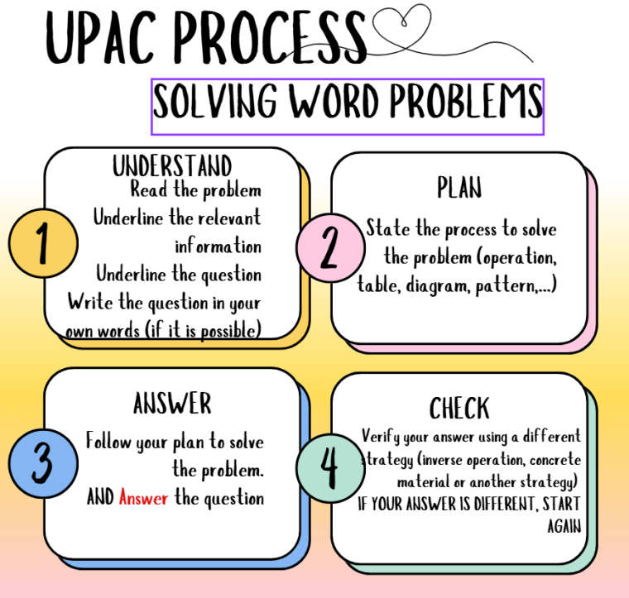

You can use this template to solve problems:

## Addition and subtraction:

### Worksheets

* <https://www.superteacherworksheets.com/addition/adding-2digit-noregroup_TTWTN.pdf>
* <https://www.superteacherworksheets.com/addition/adding-columns3_TTZDN.pdf>
* <https://www.k5learning.com/free-math-worksheets/first-grade-1/word-problems/adding-single-digit-numbers>
* <https://www.k5learning.com/free-math-worksheets/first-grade-1/word-problems/addition-sums-50>
* <https://www.k5learning.com/free-math-worksheets/first-grade-1/word-problems/addition-3-addends>
* <https://www.superteacherworksheets.com/daily-word-problems-a.html>
* <https://www.k5learning.com/free-math-worksheets/first-grade-1/word-problems/subtraction>
* <https://www.k5learning.com/free-math-worksheets/first-grade-1/word-problems/subtraction-2-digits>

## Games:

* Create your own problem and share with your family
* <https://wordwall.net/es/resource/51869249/math/math-word-problems-for-first-grade>
* <https://www.iknowit.com/lessons/a-addition-subtraction-word-problems-within-20.html>

## Videos:

* <https://www.youtube.com/watch?v=C229LUk380Q>
* <https://www.youtube.com/watch?v=s3jP0vnFSxE>

# Multiplication

### Worksheets

* <https://www.k5learning.com/worksheets/math/grade-2-multiplication-word-problems-a.pdf>
* <https://www.k5learning.com/worksheets/math/grade-2-multiplication-word-problems-b.pdf>
* <https://www.k5learning.com/worksheets/math/grade-2-multiplication-word-problems-c.pdf>
* <https://www.k5learning.com/worksheets/math/grade-2-multiplication-word-problems-d.pdf>
* <https://www.mathworksheets4kids.com/multiplication/word-problems/1-digit1.pdf>
* <https://www.mathworksheets4kids.com/multiplication/word-problems/2by1-digit1.pdf>
* <https://www.mathworksheets4kids.com/multiplication/word-problems/2-digit1.pdf>

## Games:

* <https://www.mathplayground.com/index_multiplication_division.html>
* <https://www.multiplicationgames.com/>
* <https://www.timestables.com/multiplication-games/>
* <https://www.abcya.com/games/multiplication_mine>
* <https://wordwall.net/resource/9660004/multiplication-whack-a-mole>
* <https://wordwall.net/resource/9812520/math/multiplication>
* <https://wordwall.net/resource/2567577/math/multiplication>
* <https://wordwall.net/resource/6347678/math/multiplication-maze-chase>

# Multiplication tables

We are now learning the **times tables** in Math! 🧮  
To make practice fun and effective, here are some ideas and free resources you can use at home with your children. Learning multiplication through games, songs, and daily routines helps children feel confident and enjoy Math in English.

**🎯 1. Start with the easy ones**

Begin with **2s, 5s, and 10s**, which have simple patterns.  
By 2: <https://youtu.be/o0v5o6YbYro?si=sTXAnpYniVLL-l02>

By 5: <https://www.youtube.com/watch?v=n87_WuXAzC0&list=RDn87_WuXAzC0&start_radio=1>

By 10: <https://www.youtube.com/watch?v=fRv2FMZ70Iw&list=RDn87_WuXAzC0&index=8>

**🧱 2. Make it visual**

Help her **see** multiplication by using the grid

Aqui quiero que muestres como tipo las celdas de Excel para que puedan resolver diferentes multiplicaciones, las niñas solo debe como seleccionar los cuadros de alto y de ancho y lo deben resolver con el coso visual que les dejemos, tu les muestras una multiplicación al azar de dos números entre 1 y 10 máximo, de modo que la cuadricula tendrá que ser de 100x100 por si acaso sale 10x10 y mostrarle a medida que va seleccionado la rta para que sepan.

**🧩 3. Play and learn**

* **Flashcards:** write one fact on each card (3×4 on one side, 12 on the other).
* **Card Game:** take two cards and multiply the numbers. Whoever answers first wins the pair.
* **Hop and count:** jump while saying the multiplication aloud — it helps movement and memory connect!

**📄 4. Practice with worksheets**

You can print free worksheets to review and challenge your daughter at home:

* [K5 Learning – Multiplication for Grade 2](https://www.k5learning.com/free-math-worksheets/second-grade-2/multiplication)
* [Math Drills – Times Tables Worksheets](https://www.math-drills.com/multiplication.php)

Try one or two pages a week — that’s enough!

**✋ 5. Tricks and patterns**

Help your child notice easy patterns:

* 2s = counting by twos (2, 4, 6, 8, 10…)
* 5s = end in 0 or 5
* 10s = always add a zero
* 9s = finger trick (bend one finger down → count the tens and ones!)

**🌟 6. Keep it short and fun**

Practice for **5–10 minutes every day**.  
It’s better to do a little every day than a long session once a week.  
Encourage your child by celebrating progress:

“You know the 2s! Now let’s learn the 3s!” 🎉

**💬 7. English language tip**

When helping your child, repeat the facts in English to get familiar with the structure:

“Three times four equals twelve.”  
“Five times seven is thirty-five.”

You can also write a small chart in her room with the words:  
**times – equals – product – multiply**

**🧮 Multiplication Tables (Pythagorean Table)**

The **multiplication table**, also called the **Pythagorean table**, is a special chart that helps us understand how numbers grow when we multiply them.  
It is arranged in **rows and columns**, and each cell shows the result of multiplying the number from the top by the number from the side.

For example:

* In the row for **3** and the column for **4**, we find **12**, because **3 × 4 = 12**.
* In the row for **5** and the column for **2**, we find **10**, because **5 × 2 = 10**.

This table helps children **see patterns** in multiplication:

* Numbers get **bigger** as we move to the right or down.
* The table is **symmetrical** — the result of 3 × 4 is the same as 4 × 3.
* Multiplying by **1** keeps the number the same, and multiplying by **10** adds a zero at the end.

The Pythagorean table makes learning multiplication **visual, fun, and logical**. It is a powerful tool to build confidence and speed in math.

<https://matemovil.com/wp-content/uploads/2022/01/Tabla-Pitagorica-Matemovil.pdf>

[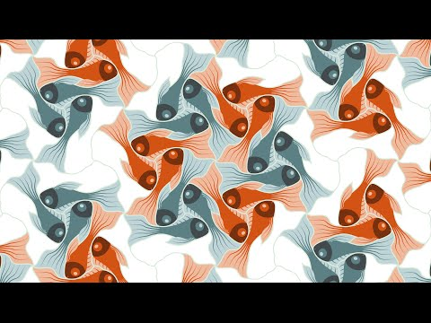](https://www.youtube.com/watch?v=7GiKeeWSf4s)